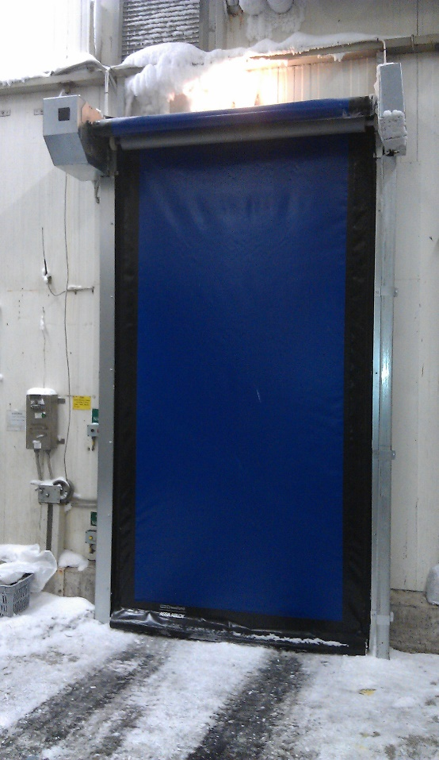

NIHVA - ASSA ABLOY – High Speed Door – HS9010PFR
(100% Imported – made in Germany)
Description:

Flexible High-performance door, opening in vertical direction for Cold Room use

Self-supporting side frames made of galvanized steel

Door curtain made of 900 g/m2 PVC with self-repairing function, ultramarine (similar to RAL 5002) or red (similar to RAL 3002).

Wind resistance: class 1 (300 Pa (N/m2)).

Water Penetration: class 1 (30 Pa (N/m2)).

Air Permeability: class 1 (24 m3/m2/h at 50 Pa).

Thermal Transmittance: 6.02 W/(m2K)

Temperature Working Range: -30 to +5 Degree

Bottom profile: Flexible Bottom Edge including wireless edge activator

Degree of Protection: Operator IP 65 & Control Unit IP54

Safety devices: 1) Photocell in Side Columns
2) Break away and self-repair function

Thermal Protection: 1) Heating Cables in side columns and motor.
2) PU Layer between side guides and Wall PU coating on springs

Opening and Closing Speed:

(open/close) up to max. 2.4/1.2 m/s

Supply voltage: 400 V 3-phase

